HELPING STUDENTS SUCCEED

It is Payne’s mission to provide a safe and challenging instructional environment to enable students to succeed in today’s world.

School counseling helps ALL children get the most out of school. Children need support in order to have a successful experience in school.

It is our goal that parents and students feel comfortable and happy to use our counseling services. I look forward to working with you.

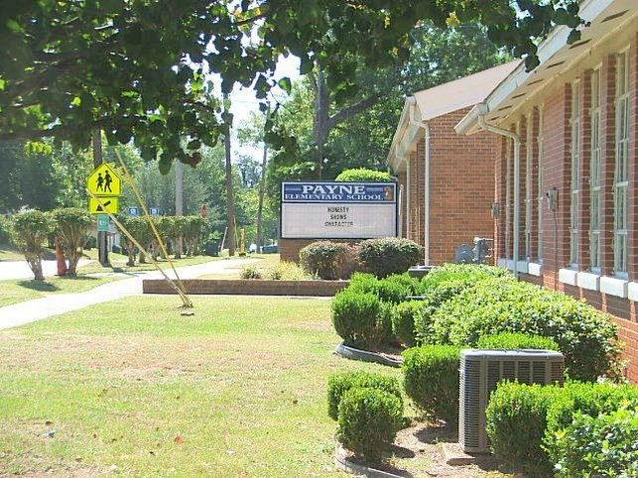

For More Information Contact:

Alicia Ward-Thomas
Payne’s School Counselor

Email:
alicia.ward@selmacityschools.org

Phone: (334)-874-1660 Ext. 3220
Fax: (334)-874-1662

Selma City Schools
Payne Elementary School
1529 Franklin Street
Selma, AL 36738
Principal Mrs. Taurus Smith

Payne
Elementary School

“Home of the Panthers”
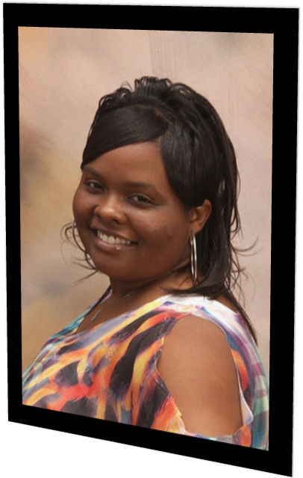

School Counseling
and
Guidance Program
Brochure
Payne’s Elementary Counseling Program

Guidance Curriculum:
Classroom lessons are developed to provide models for and instruct students for skills in career, academic, and personal/ social development for all students.
Students I am here to help you with:
- Friendships
- Cooperation
- Self-Esteem
- Making good choices
- Stress, Anger, Love
- Peer Pressure
- Bullying
Any problem you may have, I am here to help you solve it.

Parents, I am here for you too:
- Explore different ways to help your child succeed
- Improve Parent-child communication
- Information to help understand your child’s special needs
Responsive Services
These services respond and react to the immediate needs of students in terms of a crisis in the school, family or community.
- Consultation
- Counseling/Group Counseling
- Crisis Counseling/Response
- Referrals
System Support
The following activities establish, maintain and enhance the program using data to implement components in the overall School Counseling and Guidance Program.
- Consultation with Staff and/or Parents
- Consultation with Mental Health Professionals and Community Social Services Agencies
- Data gathering and interpretation
Additional Services
  - Student Council Program
  - New Student Welcome Program
  - 504 Plan Program

Individual Student Planning:

Activities are coordinated to help students, plan, monitor and manage their own learning in the areas of academic, career and personal/social development.

- Small Group Counseling
- Individual Counseling
- Parent/Teacher Conferences
- Assessments
- Student Observations
- Assistance in Monitoring Attendance

Please Note:
School Counselors do not provide “therapy” or “traditional counseling.”

